**KATALON SETUP GUIDE**

1. **System Requirements**

**Operating System:** Windows XP/ Windows Vista/ Windows 7/ Windows 8/ Linux/ Mac

**Processor:** 1 gigahertz (GHz) or faster 32-bit (x86) or 64-bit (x64) processor

**RAM:** 1 gigabyte (GB) RAM (32-bit) or 2 GB RAM (64-bit)

**Free Disk Space:** 1GB available hard disk space

**Java Version:** JDK 7

1. **Browser Support**

**Internet Explorer:** Version 8, 9, 10

**Mozilla Firefox:** Version 3.6 to version 34.0.5

**Google Chrome:** Version 36 to version 40

**Apple Safari:** Version 5.1+

**Opera:** (TBD)

1. **Setup Guide for Windows System**
2. **Install JDK**

* Download JDK 7 from [Oracle site](http://www.oracle.com/technetwork/java/javase/downloads/jdk7-downloads-1880260.html). Select the package in sync with your system (x86 for 32 bits, x64 for 64 bits).
* Double click on the package and follow the wizard to install JDK into your machine.

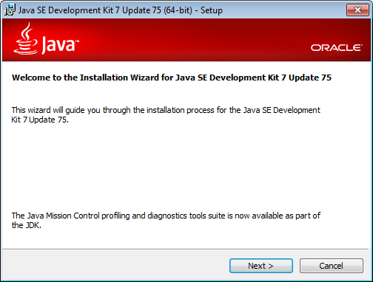

1. **Create JAVA_HOME variable**

* Right-click **My Computer** and select **Properties**

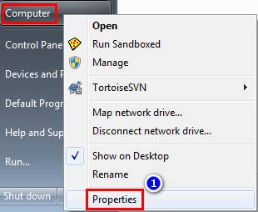

* Click **Advanced system settings**
* Click **Advanced** tab
* Click **Environment Variables…** button

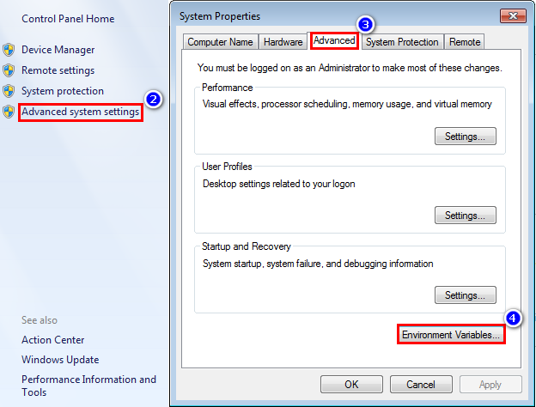

* Under **System variables**, click **New…**
* Fill **Variable name** with **JAVA_HOME**
* Fill **Variable value** with the installation path for JDK (for example, C:\Program Files\Java\jdk1.7.0_75)

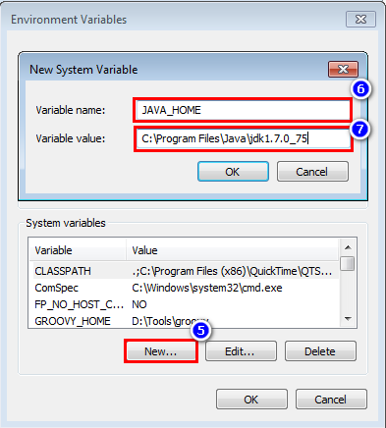

* Click **OK**

1. **Add %JAVA_HOME%\bin to system path**

* Under **System variables**, select **Path**, click **Edit…**
* Add **;%JAVA_HOME%\bin** to the end of **Variable value**

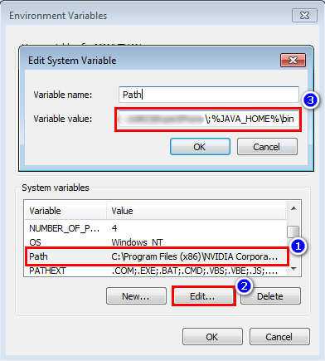

* Click **OK**

To verify the setup, open command prompt (**cmd**) and run **javac –version**, **java –version**. The result should be like the following picture.

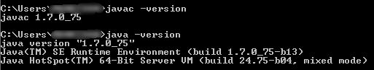

1. **Setup Katalon**

Download Katalon from <http://katalon.kms-technology.com/#/download>

Unzip the package and double click **katalon.exe** file to start Katalon Studio.

1. **Configure Internet Explorer browser**

* The browser **zoom level** must be set to **100%** so that the native mouse events can be set to the correct coordinates. 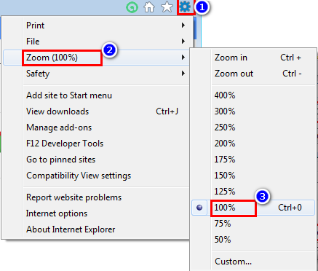
* On IE 7 or higher on Windows Vista or Windows 7, you must **set** the **Protected Mode** settings for each zone to be the **same value**. The value can be on or off, as long as it is the same for every zone. To set the Protected Mode settings, choose "**Internet Options...**" from the Tools menu, and click on the **Security** tab. For each zone, there will be a check box at the bottom of the tab labeled "**Enable Protected Mode**".

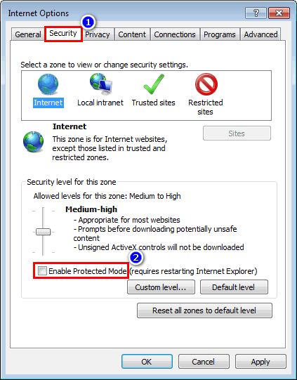

* Additionally, **Enhanced Protected Mode** must be **disabled** for **IE 10 and higher**. This option is found in the Advanced tab of the Internet Options dialog.

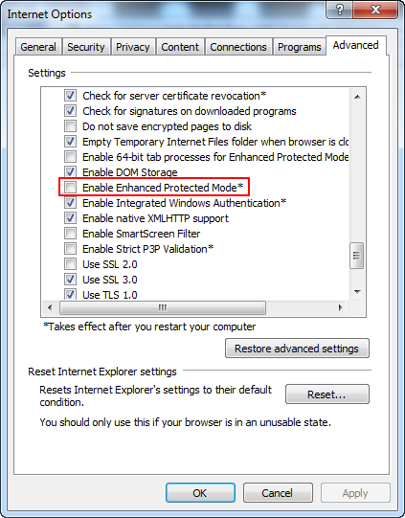

* For **IE 11 only**, you will need to set a registry entry on the target computer so that the driver can maintain a connection to the instance of Internet Explorer it creates. For **32-bit Windows** installations, the key you must examine in the registry editor is **HKEY_LOCAL_MACHINE\SOFTWARE\Microsoft\Internet Explorer\Main\FeatureControl\FEATURE_BFCACHE**. For **64-bit Windows** installations, the key is **HKEY_LOCAL_MACHINE\SOFTWARE\Wow6432Node\Microsoft\Internet Explorer\Main\FeatureControl\FEATURE_BFCACHE**. Please note that the FEATURE_BFCACHE subkey may or may not be present, and should be created if it is not present. **Important**: Inside this key, create a **DWORD** value named **iexplore.exe** with the value of **0**.

